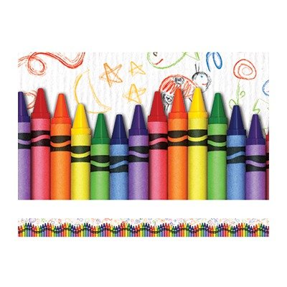

Medway Community Education presents the

**TERRIFIC TWOS**

**PRESCHOOL PROGRAM**

Ages: 2 & 3 Melanie Dawson & Irene Nelson

** A Few Openings Remain – Please Register Quickly **

Terrific Twos is a unique program developed for the younger preschool child. This program enhances socialization and hands-on learning of two and three-year-olds in a small group setting. Music, movement, stories, projects and free play are incorporated into a fun-filled morning.

Classes meet Tuesdays and Thursdays from September 18, 2018 through May 23, 2019, in the Community Education classroom located in the Burke wing of the Burke-Memorial School. Each regularly scheduled class runs from 9:00-11:30am. Children must be two years old by September 1, 2018. Snacks and drinks are provided. There is a maximum of 15 children with two teachers in this program.

Please register and pay a non-refundable $125 deposit – $100 will be applied to your May 2019 tuition. Monthly tuition is $220/month and is due on the first of each month. For additional information on the program, contact Melanie Dawson at [*melaniemdawson@comcast.net*](mailto:melaniemdawson@comcast.net).

**A1-18 $220/month**

Ages: 2 & 3 Melanie Dawson & Irene Nelson

Tuesdays & Thursdays Burke School Rm. 11

September 18, 2018-May 23, 2019 Legion Ave. Parking Lot

9:00-11:30am Door 13

***To register, visit www.medwayce.org***