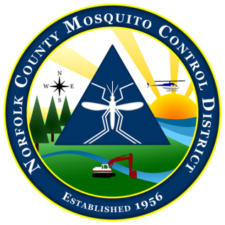
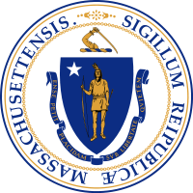

The Commonwealth of Massachusetts
The State Reclamation and Mosquito Control Board
Norfolk County Mosquito Control District
144 Production Road, Suite C, Walpole, MA 02081
(781) 762-3681 fax: (781) 769-6436
www.norfolkcountymosquito.org

Robin L. Chapell Norman P. Jacques Maureen P. MacEachern Linda R. Shea Richard J. Pollack, PhD
Commissioners

Caroline e. Haviland Field Operations Manager
David A. Lawson
Director

To: Pesticide Board & Boards of Health

From: David A. Lawson, Director

Date: May 13, 2020

Re: Notification of Late Evening Aerosol Applications (Ultra Low Volume – ULV)
Please be advised that the Norfolk County Mosquito Control District will begin the 2020 late evening ULV aerosol applications on or about May 26, weather permitting.
May 26 through October 23, 2020 - Adulticide aerosol (ULV) applications.
(Conducted between sunset and midnight, Monday through Thursday)

If any resident wishes to know what day of the week spraying may be conducted in their town, they should go to the Districts website at http://www.norfolkcountymosquito.org/service-request/. After the ULV program begins, if an individual would like to see a map of areas to be treated on the day of application, they can go to that same link, and then enter their address in the address line of the interactive map. Please note that the ULV map will be posted on or about 3:30 p.m. the day of the scheduled application.

IMPORTANT NOTICE
If you are not requesting spraying, but wish to simply be notified of spraying near your home, we have an automated notification system that will send you an e-mail if you are within 300 feet of a scheduled spray route on that evening.
In order for you to be notified, you need to provide us with your name, address, and an email address. [Note: We do not sell or distribute e-mail addresses to any outside entity.] It will be your responsibility to check your emails on the day of spraying to see if a notification is sent to you.
Please call the office to get yourself registered for this service. (781) 762-3681. You will need to re-register for this service each year.
The purpose of the adulticide application is to control nuisance and/or virus carrying adult mosquitoes. The control product being used is Zenivex (EPA Reg. No. 2724-807) applied in ultra-low volume (ULV) sprayers at a rate of approximately one ounce per acre of finished spray.
Process to Exclude Property From Public Area Wide Pesticide Applications - State Regulation 333 CMR:13:03 provides a method for homeowners to exclude their property from public area-wide pesticide applications. For more information, please click on the following links: http://www.mass.gov/eea/agencies/agr/pesticides/exclusion-of-wide-area-application-of-pesticides.html

