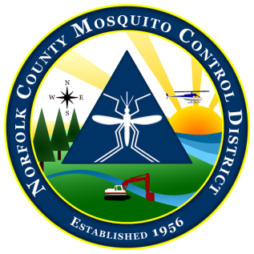
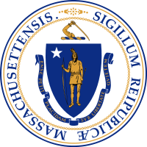

The Commonwealth of Massachusetts
The State Reclamation and Mosquito Control Board
Norfolk County Mosquito Control District
144 Production Road, Suite C, Walpole, MA 02081
(781) 762-3681 fax: (781) 769-6436
www.norfolkcountymosquito.org

Robin L. Chapell Norman P. Jacques Linda R. Shea Richard J. Pollack, PhD
Commissioners

Caroline E. Haviland
Field Operations Manager
David A. Lawson
Director

To: Boards of Health

From: David A. Lawson, Director,
Norfolk County Mosquito Control District

Date: April 6, 2022

Re: Notice of Aerial Larval Control Application

In accordance with 333 CMR 13.04 (7) (a & b), please consider this as notification of the pending aerial application targeting mosquito larvae in the wetlands in the District.

The Norfolk County Mosquito Control District will be conducting helicopter applications of the biorational larvicide Bti (Bacillus thuringiensis israelensis) to control mosquito larvae. These applications will be conducted over specific large wetlands in the Towns of:

Avon/Bellingham/Braintree/Canton/Dedham/Dover/Foxboro/Franklin/
Holbrook/Medfield/Medway/Millis/Milton/Needham/Norfolk/Norwood/
Plainville/Quincy/Randolph/Sharon/Stoughton/Walpole/Westwood/
Weymouth/Wrentham

These applications will be conducted over a likely 2 to 4-day window, lasting only 2 days, anytime between April 12, 2022, and April 29, 2022. As always, the weather in the spring is unpredictable. For this reason, the District cannot pin down actual application dates with any more accuracy at this time. We will send out further notices as the application date approaches.

The trade name of the granular formulation of Bti to be used is VectoBac GS (EPA Reg. No. 73049-10). This is not a “spray”. For further information contact David A. Lawson, Director at (781) 762-3681 or the Boards of Health in the towns listed above. Information is also available on line at www.norfolkcountymosquito.org

Respectfully submitted

David Lawson
Director

