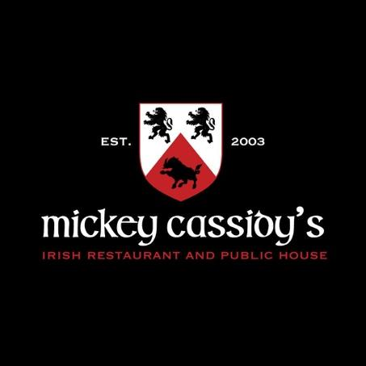
Restaurant Week Menu
$40 Prix Fixe

First Course
(Choose One)
Arugula Salad
Baby arugula, heirloom cherry tomatoes, crispy onions, 18 month aged shaved parmesan with champagne vinaigrette

Ricotta Toast
Hand dipped ricotta, prosciutto, cara cara orange segments, pistachios, hot honey and mint

Spicy Shrimp Stuffed Avocado
Hass avocado filled with spicy shrimp, english cucumber, crispy rice noodles and toasted sesame

Second Course
(Choose One)

Mushroom Risotto
Charred napa cabbage, wild mushrooms, parmesan mascarpone risotto, balsamic reduction

Shrimp & Crab Linguine
Lemon tarragon butter, baby arugula, heirloom tomatoes, lump crab and shrimp with linguine

Hoisin Ginger Pork Ribeye
Grilled pork ribeye with a hoisin ginger sauce, pineapple relish, sesame broccoli and basmati rice

Third Course

Warm Chocolate Chip Cookie
With vanilla bean ice cream

