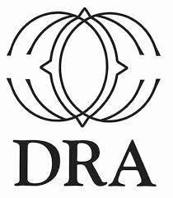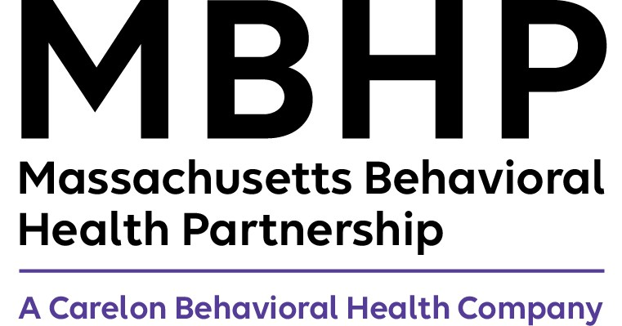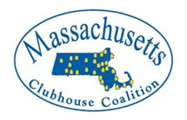

Dual Recovery Anonymous

Overview
Dual Recovery Anonymous is a 12-Step self-help program for individuals who
experience both an addiction and a psychiatric challenge. Adults working
towards wellness are welcome to attend. Massachusetts DRA embraces all
participants striving to achieve an improved sense of emotional wellbeing by
using the 12 Steps.

Looking for a local in-person DRA meeting?
Come and visit our DRA meeting right here at the Medway Town Library!
Thursdays 6:00 PM -7:00 PM (Story Room)

For a complete list of over 20 Zoom DRA meetings open to the public visit the
Massachusetts Clubhouse Coalition website at: massclubs.org

GET INVOLVED!
For more information please contact Dual Recovery Coordinator:
Julie Sprenkle PsyD at julie.sprenkle@yahoo.com

