June 6, 2022
What is CREW?
CREW (Communities Responding to Extreme Weather) is a grassroots network of local leaders across Massachusetts who are dedicated to improving climate resilience through “inclusive and hands-on education, service, and planning.” CREW aims to provide families and communities with resources to help them prepare for and respond to local climate changes in an equitable, sustainable, and collaborative manner. They organize community-based teams to engage in education, service, and planning activities and to help implement solutions at the individual, community, and state level.
CREW acknowledges the historical inequities that cause some communities to be disproportionately threatened by climate change and actively works to remove these barriers. The organization encourages local leadership when assessing issues and empowers those who have “community-specific knowledge and relationships,” in addition to promoting collaboration between the civic, public, and private sectors.
More information about CREW and getting involved can be found here: https://www.climatecrew.org/

CREW’s Connection to Medway
Last year, Medway teamed up with the Charles River Watershed Association and fourteen nearby communities to develop a flood model for the Charles River watershed. The goal of this project was to better understand possible future flooding scenarios and assess the impacts of proposed climate change mitigation measures. CREW’s main role in this effort was to raise public awareness and boost community engagement with the project. The CREW team held community meetings across the watershed area, focusing on cities and towns with environmental justice populations. Residents in these areas will be impacted the most by future flooding and mitigation strategies.
Though Medway doesn’t have any environmental justice populations, CREW still interacted with Medway residents throughout this project. CREW held an open meeting for Upper Watershed residents in April 2021. Participants noted their experiences with drought, flooding, and the yearly water bans, and some said they were excited to use the new flood model tool for their communities. One resident noted that the tool could be valuable when assessing how new Upper Watershed developments might affect the Lower Watershed region.
The flood model and more information can be found on this page: https://www.crwa.org/watershed-model.html

CREW’s Presence at Medway Pride Day
CREW hosted a table at Medway Pride Day on May 21, 2022. Visitors to the table were asked to “vote” on sustainable initiatives they would like to see in Medway. Five initiatives were presented, and each participant was given 5 beans to distribute among the 5 jars, one jar for each initiative. With 35 votes, the most popular initiative was creating new tree canopies and rain gardens. The initiative and the results are below.
- Tree plantings/canopy and rain gardens – 35 votes
  - Trees and rain gardens (see figure 1) can be planted in parks, plazas, and even along the edges of fields and buildings. Trees, other plants, and their root systems keep communities cool and healthy, in addition to preventing erosion and flooding.
  - Check out the rain garden at Burke-Memorial Elementary School!
- Transform streets (reduce/remove pavements or impervious surfaces) – 28 votes
  - The goal of this initiative is to make Medway’s streets more eco-friendly. Paved streets, sidewalks, and parking lots trap heat and keep water from being absorbed by the earth, causing health and flooding issues. The current infrastructure can be replaced with permeable pavers, green spaces, gardens, bioswales (water runoff area) to reduce these problems. (see figure 2)
- Composting/food waste program – 26 votes
  - Composting decomposes food waste aerobically. It reduces landfill waste, decreases emissions, and produces quality soil for gardening. A municipal program (see figure 3) might include waste drop-off sites, curbside pick-up, and/or support for community members with on-site composting.
  - Medway hopes to start a composting program soon with community support!
- Solar parking canopies – 21 votes
  - Solar parking canopies are covered parking areas with solar panels on them (see figure 4). Like other solar panels, these canopies have photovoltaic panels and an inverter to convert electricity. Some also have meters to track how much energy is being created. And they provide shade and protection when hot or rainy outside!
  - See a solar canopy in action at the Medway DPW Garage!
- Electric municipal fleet – 17 votes
  - Medway is considering upgrading the city’s vehicles to run fully on electricity, versus gas or diesel fuel (see figure 5). An electric fleet would support less emissions and pollution, especially if the town purchases electricity from clean, renewable sources (e.g. solar, wind).
  - Medway already has two electric vehicles in its fleet, both 2019 Nissan Leafs. We also have four EV charging stations at: Town Hall, Library, Choate Park and Oakland Park.
Note: There was a total of 127 votes though only 125 should count because 25 people participated.
Share Your Vision for Medway: What does and can make our communities healthier, stronger, and more connected?
Visitors to the table were also asked to write their thoughts in response to the above prompt on sticky notes. Their responses are below.
- “Sidewalk installation on Village [Street]”
- “Intergenerational connections and wisdom sharing (eg: youth and elders planting community garden together)”
- “Confiscate oil company profits for free solar panels”
- “Neighborhood open space parcels. Label/sign existing lots in neighborhoods and cul-de-sacs.”
- “Rainwater harvesting for outdoor watering”
- “Contract with recycling company for fabric, clothing, shoes”
- “More arts and music events, celebrating culture and diversity! (neighborhood dance parties!)”
- “No restrictions on home wind turbines <50ft < 50kW”

FIGURES
Figure 1 - Rain Garden at Burke-Memorial Elementary School (left), Tree plantings (right) | 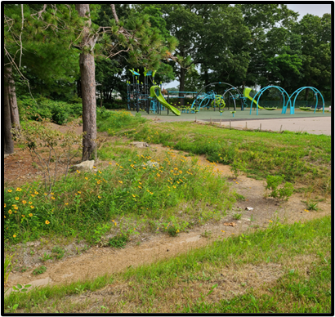 | 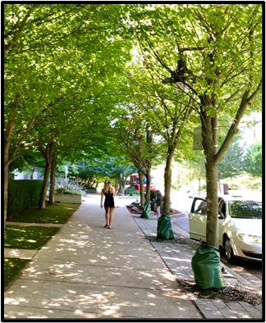
Figure 2 - Transformed Streets in Watertown | 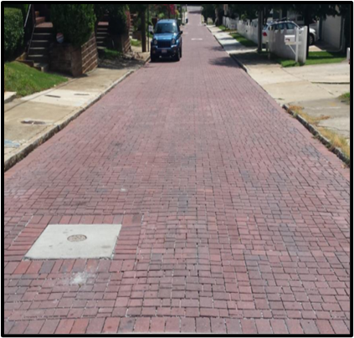 | 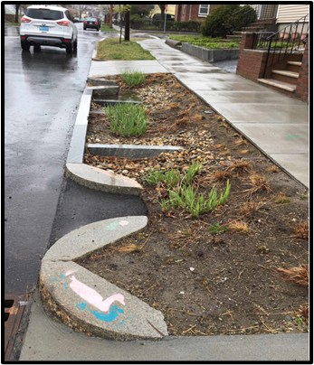
Figure 3 - Composting System | 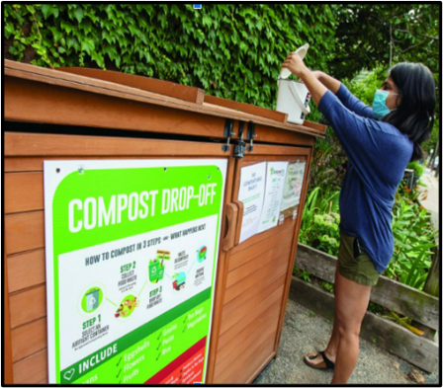
Figure 4 – Solar Parking Canopy at Medway DPW | 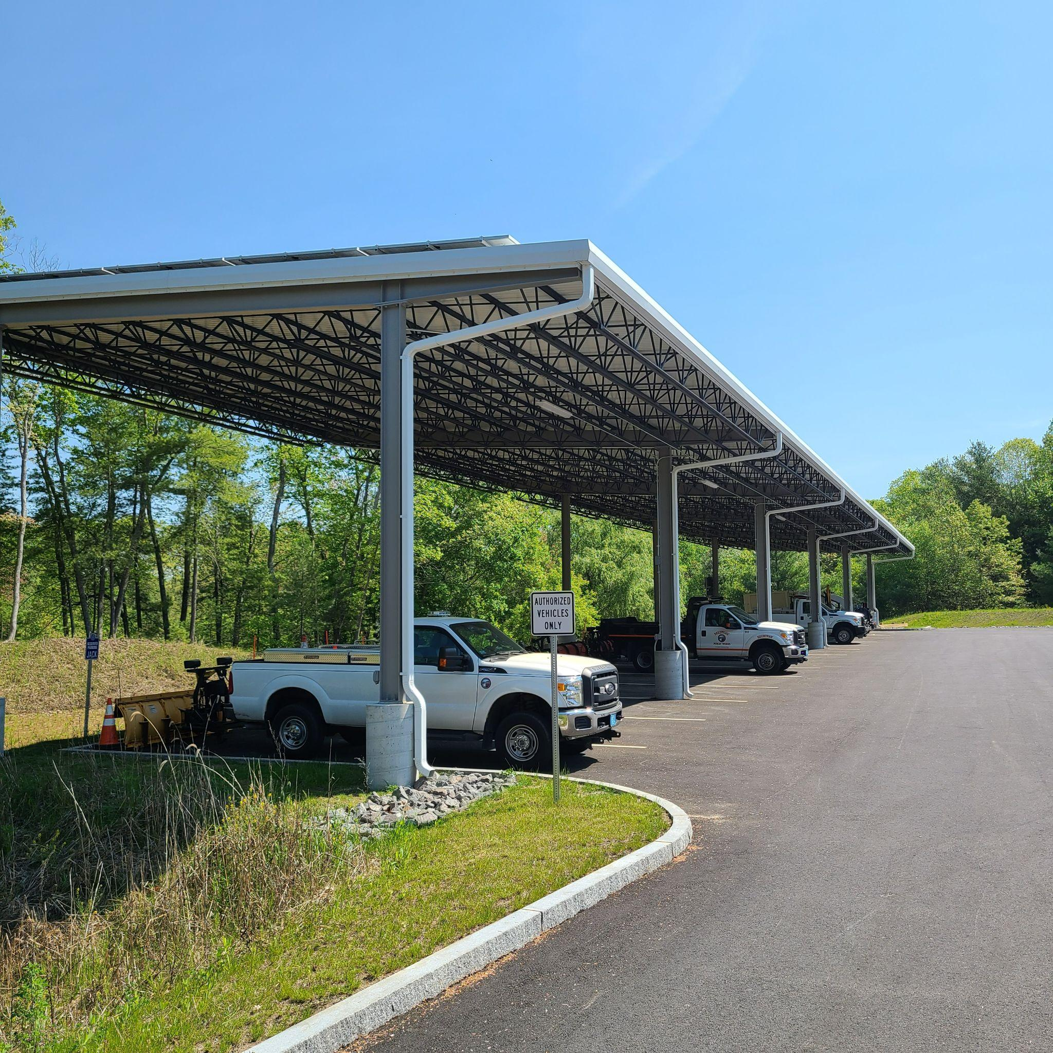
Figure 5 – Electric Vehicles | 