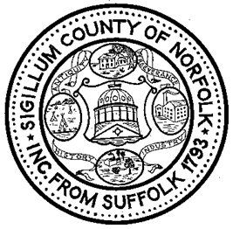
Norfolk County Registry of Deeds
William P. O’Donnell, Register
Medway Office Hours

Thursday, February 27, 2020
10:00 AM – 12:00 Noon

Medway Town Hall
SANFORD HALL
155 Village Street

The Register and members of his staff will be available to help answer questions or concerns about any Registry of Deeds matter.
Information will be available concerning the Massachusetts Homestead Act and internet ready computers will be on hand to print a Registry recorded deed, confirm the status of a
mortgage discharge or check on any other filing.

No appointment is needed.

To learn more about these and other Registry of Deeds events and initiatives like us at Facebook.com/Norfolk Deeds or follow us on twitter.com/Norfolk Deeds
Call the Registry for further information at 781-461-6104
or visit the Registry’s website www.norfolkdeeds.org

