Medway Christmas Parade Committee
C/O 36 Alder Street
Medway, MA 01747

October 19, 2020

Business
Street address
Town, MA Zip

Dear Donor/Name,

The Medway Christmas Parade Committee hopes you and yours are well and safe! We pray that everyone is making it through this historic Covid-19 crisis in a safe and healthy manner.
As would be normal during the past 28 years, our committee would be up to our necks in planning for our Christmas Parade, especially with regards to the fund-raising efforts needed to support our parade!
However, as with most things since the start of this Covid-19 Pandemic, major changes have been necessary effecting all aspects of our daily lives. Now especially the Medway Christmas Parade. Major local and state mandates have limited the ability of conducting daily activities now, including our parade.
Yes, there will be a Christmas Parade!!! However, not as we have become accustomed. This year, there will be no fireworks display and no festivities at the Thayer House and Choate Park. A parade will take place in as much the same fashion as is past years, but with necessary modifications.
The elimination of festivities at the Thayer House and Choate Park including Fireworks have reduced the majority of the funds needed by 2/3’s.
Because of this, the parade committee is able to rely on the small balance of funds remaining in our account to fund the remaining costs for this year. Therefore, we wish to advise that for 2020 no funds will be solicited.
The Christmas Parade Committee wishes to express our most sincere appreciation for your past support, and hope you will consider supporting us again next year. Without you, there would be no Christmas Parade!

Thank you! Thank you! Thank you!

Wishing you a healthy, Safe and Prosperous Christmas Season!

Regards,
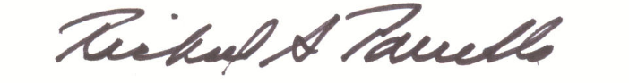

Richard A. Parrella
Sec/Treas.

