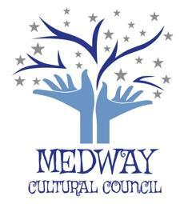
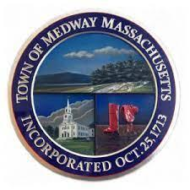
TOWN OF MEDWAY
COMMONWEALTH OF MASSACHUSETTS
Medway Town Hall
155 Village Street – Medway, MA 02053

Medway Cultural Council
medwayculturalcouncil@gmail.com

October 28, 2021

MEETING NOTICE
Tuesday, November 2, 2021 @ 7:15 p.m.
Medway Middle School, Presentation Room - 45 Holliston Street
(Enter through Door #7 from the parking lot on the south side of the building)

AGENDA
- Approval of Minutes from October 2021

- Officer’s Report: Treasurer’s Report, Co-Chair’s Report

- Grant Liaison Report (Karyl Wong): update on Grantee’s progress and schedule, grant
regulations and timeline for previous approved grants.

4. Review Process for Grant

5. Consideration of a new Word Press site: Kim and Valerie

6. Fall Photo Contest: Details of contest

7. Artist Auction: (Kim) - details of auction
- Bench Placement (Gail)

- Other business as may come before the Committee

- Topics for future a) priorities for 21/22; b) strategies; c) allocation of town/donation funding

- Adjourn

Masks are required for anyone attending the meeting whether or not vaccinated.
Seating will be available for the public.
Attendees can arrange their seats to accommodate their needs.

