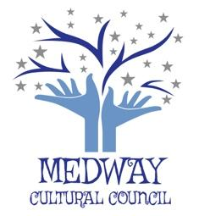
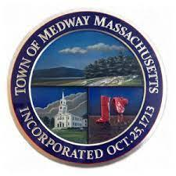
TOWN OF MEDWAY
COMMONWEALTH OF MASSACHUSETTS
Medway Town Hall
155 Village Street – Medway, MA 02053

Medway Cultural Council
medwayculturalcouncil@gmail.com

November 11, 2021

MEETING NOTICE
Tuesday, November 16, 2021 @ 7:00 p.m.
Medway Middle School, Presentation Room - 45 Holliston Street
(Enter through Door #7 from the parking lot on the south side of the building)

AGENDA
- Approval of Minutes from November 2,2021
- Guest: Andrea Poisson Delucia author.

- Officer’s Report: Treasurer’s Report, (Hazel), Co-Chair’s Report
- COASST-Second Act Inc/substance use disorder (Hazel)

- Grant Liaison Report (Karyl Wong): update

- LCC Grant: access, list, and evaluation (Gail)

- WordPress: Update

- Electrical Boxes

9. Artist Auction: - update from Kim’s research, Gail’s meeting with Willows.

10.. Statement of Diversity for Master Plan.

11. Spotlight: Subject Choices, frequency.

Adjourn

Masks are required for anyone attending the meeting whether or not vaccinated.
Seating will be available for the public.
Attendees can arrange their seats to accommodate their needs.

