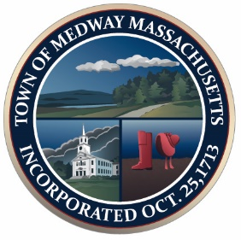

Town of Medway

Commonwealth of Massachusetts
Council on Aging Board

Medway Council on Aging
76 Oakland Street
Medway, MA 02053
Phone (508)533-3210

www.townofmedway.org

Committee Members
Mary Staples, Chairman
Veronica Clark, Vice Chair
Judy Lane, Secretary
Pam Balabanis
William Caton
John Clark
Siri Krishna Khalsa Ronald Lane
Grace Rossetti Charlene Tingley

AGENDA:

NO MEETING ON
March 9th at 2:00 PM.

The Council on Aging Board will not meet on March 9 2021, the next meeting will be April 13 2021.

All meetings are held at the
Medway Council on Aging (76 Oakland St)
On the 2nd Tuesday of every month at 2:00 PM

