Medway Energy Committee
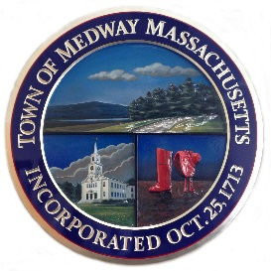
Carey Bergeron, Chair
Lawrence Ellsworth, Member
Alex Siekierski, Member
Kristen Rice, Member
Stephanie Carlisle, DPS
Anh Le, School Com
John Foresto, Bd Slctmn
Robert Tucker, PEDB

Town of Medway
155 Village Street,
Medway MA 02053
Tel: (508)-321-4871

MEETING AGENDA
Wednesday February 20, 2018
Medway Public Library
7:00 PM
1. Call to Order
2. Report from the Chair
3. Reports from Members
4. Ongoing Project Discussion:
- Municipal Community Choice Aggregation
- Green Communities grant update
5. New Business
a. Mission Statement and vision statement discussion
6. Action Items
7. Future Topics / other business
8. Adjourn
UPCOMING ENERGY COMMITTEE MEETINGS:
Wednesdays –
March 20, 2019; April 17, 2019

The listed matters are those reasonably expected by the Chair to be discussed at the meeting. Not all of the items listed may in fact be discussed, and other matters not specified may be discussed and considered to the extent permitted by law.

