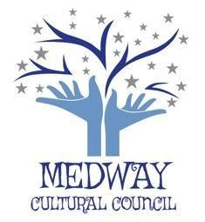
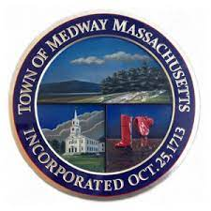
TOWN OF MEDWAY

COMMONWEALTH OF MASSACHUSETTS
Medway Town Hall
155 Village Street – Medway, MA 02053

Medway Cultural Council
medwayculturalcouncil@gmail.com

June 13, 2022

MEETING NOTICE
Tuesday, June 21 ,2022 @ 7:00 p.m.
Cole Room, Medway Public Library
.
AGENDA
- Approval of Minutes from May 3, 2022
- Officer’s reports - Treasurer’s Report - Hazel Warnick, Co-Chair’s Reports, Gail Hachenburg, Jordan Warnick
- Update on Choate Park murals. Meeting with P&R, etc. - Gail Hachenburg, Mike Cannistraro, Jordan Warnick
- Update on ’21 and ‘22 grantees - Grant Liaison, Karyl Wong (Art at Choate Park)
- Priorities for Grants 2023 - Gail Hachenburg, Jordan Warnick
- Medway Cultural Council Grant Application FY’22 - Jordan Warnick, Gail Hachenburg
- Update on Social Media sites - Valeria Shinas, Celeste Falco
- Medway Celebration Day, Follow-Up - Judy Moffatt, Gail Hachenburg
- Spring Photo Contest - Jordan Warnick, Gail Hachenburg
- Representation on NAIP committee (Appointment Process) -
- Update on Signal boxes - Amy Rochford, Crystal Buckley
- Monitoring Mass Creative Update Sessions - Hazel Warnick
- Other Business
- Topics for future meeting agendas including a) priorities for 21/22; b) strategies; c) allocation of town/donation funding; d) recruitment of new members Gail and Jordan

Adjourn

The listed agenda items are those that are reasonably anticipated by the Chair to be discussed at the meeting. Not all the listed items may in fact be discussed. The order of items may be adjusted. The Council may address and consider other matters not specified to the extent permitted by law.

Future Medway Cultural Council Meetings

First and Third Tuesdays of the month @ 7:00 p.m.

Jun 21 Cole Room, Medway Library (one meeting in June)
July 19 Cole Room, Medway Library (one meeting in July)
Aug 2 Cole Room, Medway Library
Aug 16 Cole Room, Medway Library

