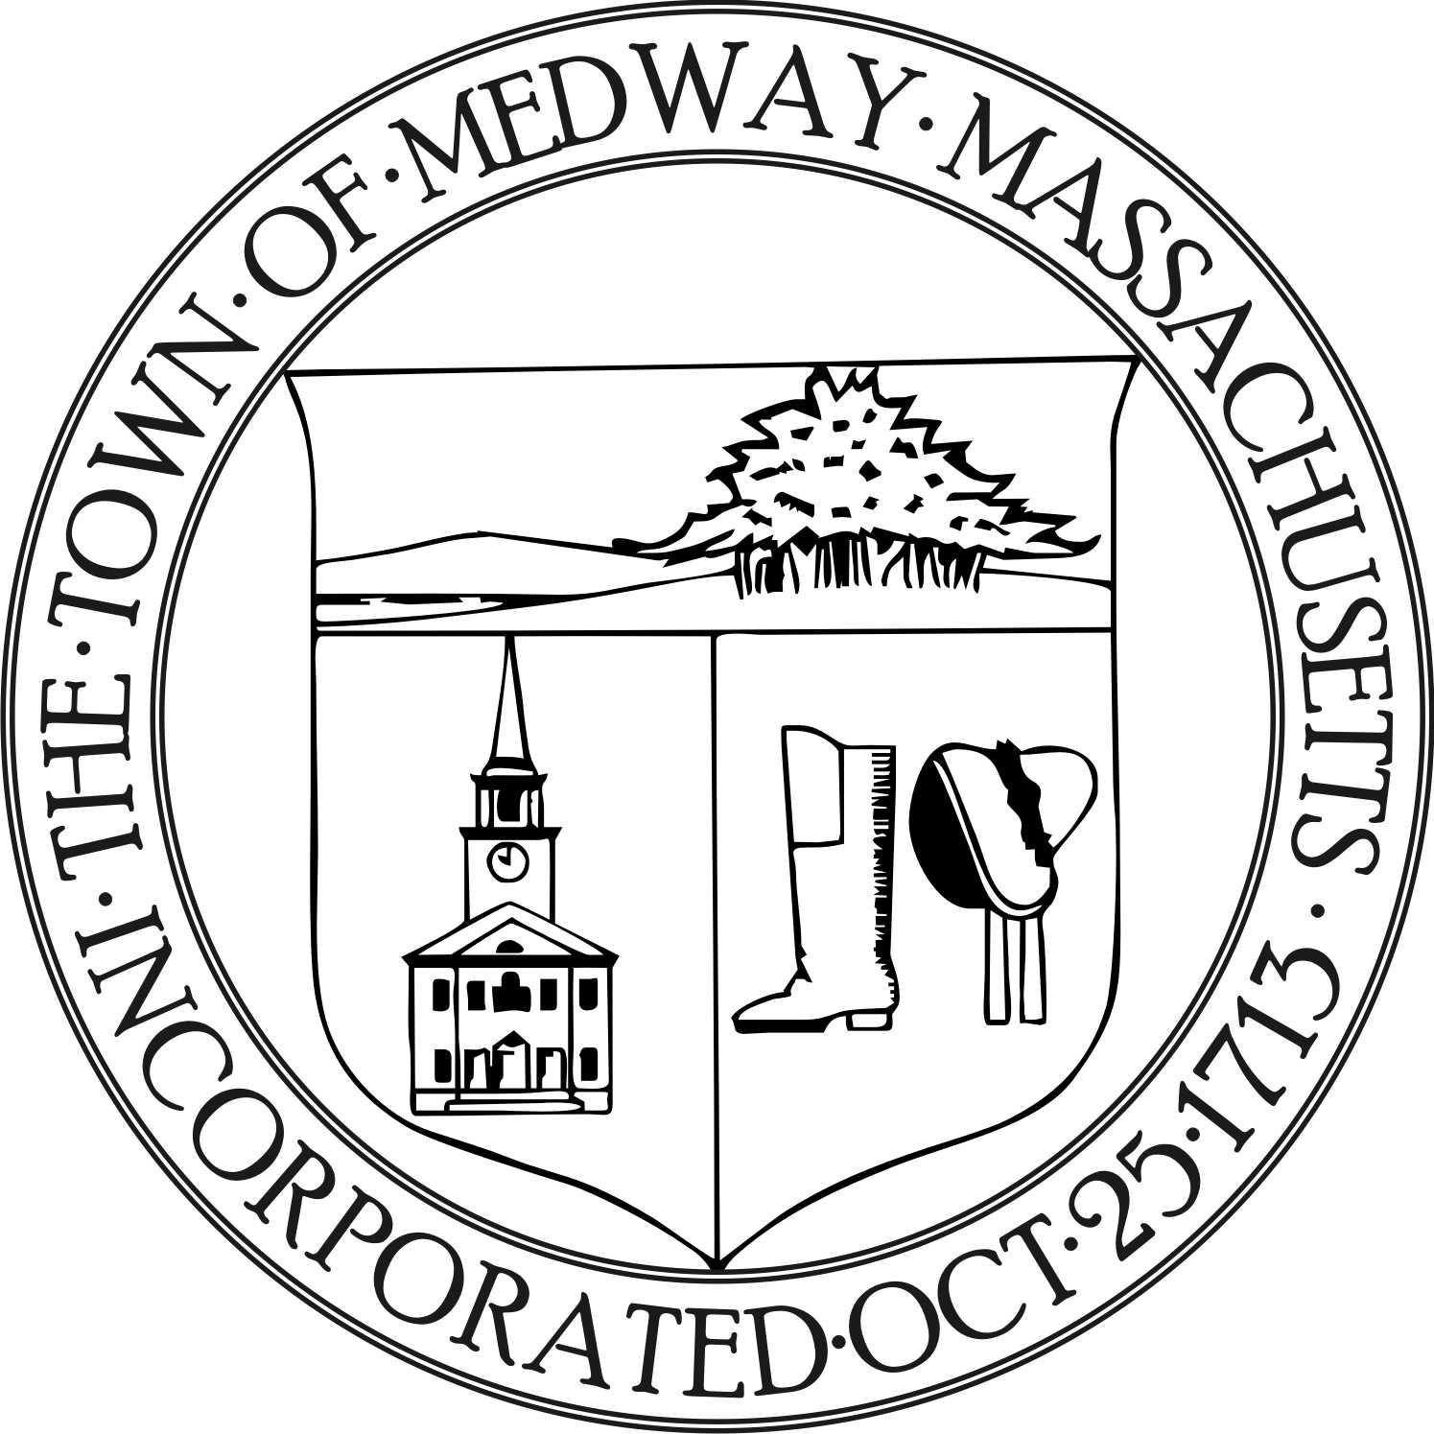

Medway Energy & Sustainability Committee
Medway Public Library, Conference Room
August 21, 2019 at 7:30 PM

Members present: Carey Bergeron, Lawrence Ellsworth, Alex Siekierski,
Kristen Rice, Stephanie Carlisle, and Tracy Rozak, Recording Secretary

Also present: David Travalini, ConCom Chair

- Call to Order
Carey Bergeron, Chair called the meeting to order at 7:32pm.
- Report from the Chair
Carey reported that she filled out the application for membership to the Charles River Climate Compact.

- Reports from Members

- Ongoing Project Discussion
- Green Communities grant update
Stephanie stated the grant has not been awarded yet.
- Community Choice Aggregation

Nothing new to report

- Update the group on the Charles River Climate Compact meeting (8/1/19)
Kristen informed the group about the things they discussed at the Charles River Water Shed meeting. They discussed how towns are trying to form a group to prioritize actions item and move them forward. They also discussed how they you use the Charles River and the importance of it and how the Watershed association can help with climate related items. Members from the DPW were there and discussed stormwater issues. Kristen mentioned that Jillian from Natick would be a good person to contact as she talked about all the changes they have done with heat sources and the green community. We should be thinking about what we would like to accomplish this year or a five year plan. Natural storage areas are important and we don’t have flash flooding like some other rivers do. The Army Core of Engineers designed the river crossings during the 1960s and did some widening and dredging. Kristen stated there may be another meeting scheduled for the fall.
- New Business
Stephanie will invite Emily Kibb from Environmental Massachusetts to the September meeting.

- Share the EV charging station use
Stephanie reported the EV charging stations went live in January. The spent $1,000 dollars in electricity for both stations. It’s free for anybody to use. The Town hall station gets more use than the library one does. There were 64 different people that used their ID to charge their vehicles. It would be good to research who is using these stations, town employees, out of town residences etc. Would more charging stations be needed. It would be a good idea to do some PR about these. ChargePort makes the stations and they have yearly contracts. The Annual cost is $2,500.
- Determine the GHG emissions avoided since becoming a Green Community
They will discuss this at a later date after they review all the data.
- Discuss the feasibility of a curbside compost program
They will discuss this at a later date after they review all the data.
- Review the Town-wide building audit scope of work
The committee members will review this before the next meeting. They will create a Google document to put their comments on.
- Review MEI data
Stephanie stated the overall use is baseline 2009 and you can see the reduction every year. They met the 20 percent decrease. This data is weather normalized. The middle school and the high school are high use.
Review the Meeting Minutes from the 6/26/19 meeting.
No meeting minutes were reviewed at this meeting.
- Future topics / other business

- Discuss Temperature Set Point Policy
They will discuss this after they review the data.

- Plastic bag ban update
Carey stated that John Forresto stated he would draft a warrant article for them. Carey will follow up with him on that.

- Continue discussing the option of a solar panel regulation
They will discuss this at a later date.

- State of the Town report items
Not discussed

Action Items
- Stephanie will invite Emily Kibb from Environmental Massachusetts to the September meeting.
- All members will look at the data from the Town-wide building audit scope of work and make comments before the next meeting.
- Carey will check with John Forresto on the Warrant Article regarding the plastic bag ban.
- Stephanie will talk to Susie about design standards /esthetic requirements.

Adjourn
Carey made a motion to adjourn the meeting at 7:35 pm. Larry seconded the motion and it was voted to approve 4-0-0.

The next meeting will be on September 18th at 7:00 pm.

Respectfully submitted by,

Tracy Rozak
Recording Secretary

