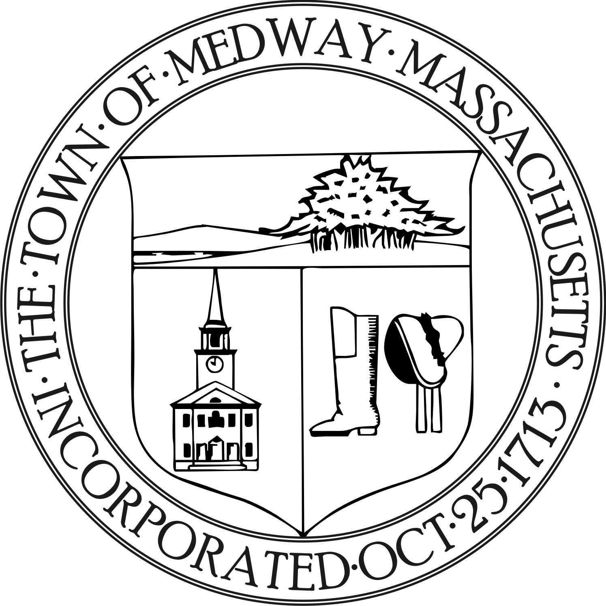

Medway Energy & Sustainability Committee
Town of Medway
155 Village Street
Medway, MA 02053
Tel: 508-533-3264 / Fax: 508-533-3281

Meeting Date: April 17, 2019
Meeting Location: Medway Public Library
Approved:
Attending: Carey Bergeron, Chair, Larry Ellsworth, Kristen Rice,
Alex Siekierski, and Tracy Rozak, Committee Secretary
Absent: Stephanie Carlisle
Also Attending: Mark Cappadona, Colonial Power Group
_____________________________________________________________________________________

- Call to Order

- Carey Bergeron called the meeting to order at 7:07 pm.

- Report from the Chair

Carey thanked everyone for getting their ethics in. Larry and Carey are both up for re-appointment.
They both plan on staying. There are still two or three seats available on the committee.

Carey state she looked into getting straws for Medway Pride Day. They are a possibility but we would not be able to get hundreds of them. Alex will finalize the new logo and design within the next few weeks and Carey will get a new banner made at Staples in time for Medway Pride Day. They also have pinwheels and candy left over from last year.. Kristen will work on doing a prize wheel. It will be a “Did you know?” type of wheel. Kristen went around to some local business and asked about posting a “Did you know?” flyer about earth day and some of them were open to posting to them. She posted some around town.

Alex asked if we should create business cards to pass out at Medway pride day. They could also make another type of handout to pass out as well. The group discussed the schedule for Pride Day. Set up starts around 9 and it goes from 10 until 4pm. Carey and Larry can cover the morning and Kristen and Alex can cover the afternoon. Carey will come back for the last hour and help break everything down. Stephanie got the booth and we will be located next to DPW. Kristen stated she sent an email to the Green Team about the Clean Sweep and she will follow up with them tomorrow.

The group discussed and decided they should move forward and talk with Michael Boynton and the board about aggregation.

- Larry made a motion to work with the town to discuss the aggregation. Alex seconded the motion and it was voted to approve 4-0-0.

Carey stated she went to the Cambridge Science Festival and met a man that has a fully sustainable restaurant in the North End. He is working with the local schools to get rid of single use plastic bottles and serving trays. He tries to push the water fountains that fill your own water bottles. He also wants to see them use more of their own composting. He is also building a new restaurant in Chelsea that will be fully sustainable. He also offered to help us with any initiatives. It would be a good idea to look at what other towns are doing and see how much they are saving. Alex stated the town is planning on replacing the roofs on the Burke and McGovern schools-– might want to get them to use solar panels.

Carey stated they are not ready at this point to go to the board with Dave Travalini’s suggestions from the last meeting but they will keep it on the table.

- Report from Members

Larry mentioned the bids on the building. The total cost estimates were 1.5 million to buy and install but as the project has gone along and the bidding got tighter, the price of panels has dropped. Last he heard they were at $ 960,000. The bond issue of 14 million includes the panels as well. They should get energy credits they can apply to other buildings. Hopefully we won’t be any snow storm or cloudy rainy days. The panels are sized to support the building load. The building still has to be approved at the town meeting and the design is almost finished. Tuesday evening the building committee is meeting to review it.

- Ongoing Project Discussion

- Municipal Community Choice Aggregation | Mark Cappadona

Mark distributed a data status report of Q1, Q2, and Q3 for 2018. This showed the aggregate savings by residential class. Mark also gave an update of the market place. He stated Boston is going to pull out of their basic service and they are shooting for January first start. He is not sure how this will affect prices but the prices will rise over the winter. What do we want to do? As a safety measure, he suggested we go back through the process, re-hang the plan and have selectman vote on the plan, answer questions and get another order. Whether we go forward is up to the town but everything will this will be ready, sort of a defensive play just in case. This is just the preliminary steps to go to market. Last year he thinks we were at 11.7 and National Grid was at 10.8, he thinks they will be at 11.7 again. Larry asked what Mark would recommend for a term. Mark stated he finds that 24 and 36 month terms seem to work the best. People like the stability and security of that. It may look like your paying more upfront but actually paying less over time. People also can opt out or back in at anytime. Only a small handful of his customers in Marlborough go in and out all the time in an effort to save money- you might save $3 per month. Larry asked if they could join another group like Southeast Mass or another consortium. Mark stated we can once they have their order but you would need to contact them directly. Carey stated it would be worthwhile to look at the other towns around us. Mark can send us that information.

Larry stated the town decided to buy the solar panels ourselves rather than rent them. They can’t monetize the tax credit because they are a municipality. It is just easier for the town to buy their own.

B. Green Communities grant update

- New Business

- Action Items

- Future topics/ other business

- Meeting Minutes

No minutes were approved at this meeting.

- Adjourn

- Larry made a motion to adjourn the meeting at 8:15 pm. Kristen seconded the motion and it was voted to approve 4-0-0.

*Next meeting will be on Wednesday, May 15, 2019 at 7:00 pm at the Medway Public Library.

Respectfully submitted by Tracy Rozak

