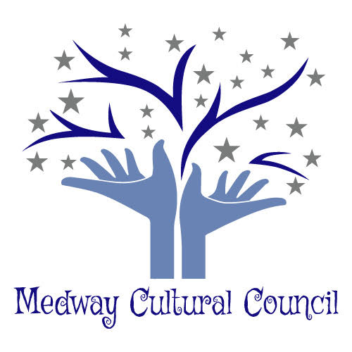
Medway Cultural Council
155 Village Street
Medway, Ma. 02053
Meeting Minutes

Cultural Council Meeting was held at the Medway Public Library, Medway, Ma.
Date: June 6, 2019. Meeting was called to order at 7:12p.m.
Present: Carla Cataldo, Gail Hachenburg, Karyl Wang, Jennifer Kendall, Becky Atwood, Mary Weafer, Phil Giangarra, CanMan, Jordan Warnick and Hazel Warnick.

1. Minutes from April meeting were approved.

2. Treasurer’s Report
Melissa sent her report via email.
a. All expenses received for Art Week were remitted and should be paid by now.
b. She received the one additional reimbursement request.
c. As of Tuesday, there were no new reconciliations available and no new expenses.
d. There was a thank you note form Emily Midgely on behalf of Pride Day thanking the CC for our support of that event.
d. Melissa is finding that her working is taking her away on travel much more often than in years prior and she would like to have someone else assume the treasurer position.
e. Phil volunteered to assume the position. A motion was made and seconded for Phil to assume the treasure’s position pending his being sworn in to the CC.
f. The motion was accepted to reimburse Gail $67.15 for the logo and postage for the
thank you notes sent to the artists who participated during Art Week.
Action Item:
Phil will be sworn in and then assume the position of Treasurer.

3 Art Week Debrief
Art week was well received. The following suggestions were made to improve next year’s Art Week.
1. To increase amount and frequency of publicity. (Local newspapers, banners, flyers etc.)
2. To reserve dates and times for the Thayer Historical House now for both weekends of Art Week and then to research scheduling activities at the Senior Center and Library.
3. To form a subcommittee.
4. Carla requested that each member who assisted in Art Week submit a list of his or her responsibilities during last Art Week, so that we have a master list.
Action Item:
Members will submit a list of his/her responsibilities to Carla who will then create a master list for next year’s Art Week.

4. Town Meeting Update.
The Town has appropriated $5,000.00 stipend to the Cultural Council.
Carla is meeting with that group to discuss the possibility of obtaining a grant to gain more funds to infuse art throughout the town. There is a possibility of obtaining $25,000 of grant money from the federal government and then the town would match the grant fund.
Action item:
Carla will report back to us regarding the status of the grant.
Carla will send an e-mail for the June 18th meeting at Town Hall.

5. Public Murals, Can Man
Canman presented his research on creating public murals.
a. He presented the reasons why the stone tussle can’t be painted on.
It’s a west-facing wall and there would be significant UV damage.
Difficulty painting on the Stonewall due to weather related issues, water seepage,
etc.
b. Research on Utility Boxes Mural Project.
CanMan explained that there are application requirements for longevity and to keep the murals intact. The process consists of sanding down the boxes, application of a basecoat, then painting the mural. Then second part consists of varnishing, which is an anti graffiti medium as well as protects from the UV rays. He also relayed that he would do the math and obtain prices for the paint. He estimated that the low end would cost about $500.00 and the high end could be $7,000.00. Gail suggested that we include a maintenance fee. CanMan showed examples of his artwork for the electrical boxes. The committee discussed art themes, conceptual ideas. Becky suggested getting artists involved. Gail mentioned Judy Moffett who did the Mandela’s during art week.
c. Also discussed were creating banners for the lampposts on 109.
d. Mary suggested to use a panel attach to brick buildings in town.
e. Locations for displaying artwork were:
Flag poles, Choate Park, electrical boxes on 109.
Action Item:
CanMan will get back to us regarding the price of painting murals on the electrical boxes.
Gail, Becky and Karyl will research banners and prices.
Carla will form a subcommittee for this project.

6. Volunteers & Projects.
Carla invited Hazel and Jordan Warnick to the CC meeting to see if they would like to become members and work on time table for projects. They will look into making a time line/action plan for the “M” fundraiser project so that the “M” pieces will be on display during Art Week.
Action Item:
Karyl will send Hazel and Jordan the information she has.
Carla will provide them with information from Julie Deheney.

7. Other
A. Jennifer, who is also on the Economic Development Committee relayed that the EDC would like to partner with the CC to have cultural displays during the Ribbon Cutting Ceremony for Choate Park on 9/14 at 11:00 a.m. (alternate date TBD sometime in October).
Action item:
At our next meeting, Jennifer will provide more information about the ceremony and what type of involvement or assistance the CC could provide.

B. The CC members discussed the need for having stationary and banners with our logo. It was agreed that Gail, Becky and Karyl would research the type of banner, costs and where to purchase them.
Action item:
Gail, Karyl and Becky will research the above information about the stationary and banners with our logo and then report back at the next meeting.

The next meeting will be held on August 20,1019.

Respectfully submitted
Gail Hachenburg,
Secretary

