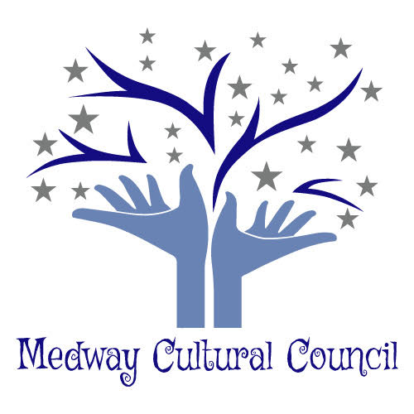

Medway Cultural Council
155 Village Street
Medway, Ma. 02053
Meeting Minutes

Cultural Council Meeting was held at the Medway Public Library, Medway, Ma.
Date: December 9, 2019. Meeting was called to order at 7:05 p.m.
Present: Carla Cataldo, Gail Hachenburg, Karyl Wong, Jennifer Kendall, Jordan Warnick, Hazel Warnick, Phil Giangarra, Mary Weafer and Kim Blenkhorn.

1. Minutes
Minutes from November 2019 meeting were amended and then approved.
ArtWeek Subcommittee November minutes were approved.

2. Officer’s Updates and Reports

a. Treasurer’s Report
Phil reported that we have two accounts. One of the accounts has $5,000.00
and the second account has $2074.22, giving our combined accounts a total of
$7,074.22.
Sarah Stone has requested paper work to submit for her invoice. Apparently,
there is some confusion about the process that is used to file and then pay
the Grantee’s.
Jordan was given the tax exemption Id number so that he could order business
Cards.

Action item:
Phil will do the financial report for the state.
Phil will talk with Melissa and learn about the process used to file and then
pay Grantee’s.

b. Secretaries Report
The banner has been ordered and should be ready by the end of this week.
Shelia Dubrawski has requested a Grant Extension to file the reimbursement
Documentation. Carla thought that Shelia would not need an
extension and would have enough time to file for reimbursement. However,
if it should happen that Sheila does need the extension, the CC will grant that
extension.

C. Chairperson
Carla reported that the fall Board of Selectman Meeting did a recap of this
year which included a video of our ArtWeek.
Action Item:
Carla will attend the upcoming Town Meeting and provide an update about
the Cultural Council’s activities, which will include: ArtWeek, Grantee’s
and other items such as financial report.

d. Grantee Liaison
Discussed asking Grantee’s to participate during ArtWeek or possibly
scheduling their programs during ArtWeek.
Karyl will send out letters to the Grantee’s as well as set up a
calendar of events.

3. ArtWeek Subcommittee
Jennifer relayed to the group that the Chairperson of the EDC told her that there is a benefactor that would like to donate a sum of money to our committee, however there are some conditions that would need to be met.
Also discussed was the possibility of having an open studio day since the Library has
Reserved for May 2, 2020 from 10:00 a.m. to 2:00 p.m. Also mentioned is that we need to have a connection with the ArtWeek website.
Jordan has been in contact with Kristin regarding using the Medway High School Gym (or the middle school gym) as a location for ArtWeek events.
Other locations in Medway that were discussed were the Thayer Historical House if
we had funds to pay for it, the VFW, Saint Joseph’s Parish or local churches.

Also discussed was how to contact different artists, businesses etc. The members reviewed the three letters crafted by Jennifer, Jordan and Hazel which would be sent to the different businesses in town informing them of ArtWeek and how to apply.
Jennifer has made an account for MCC to join the Community Partner for ArtWeek.
Also discussed was the amount of funds that are available for ArtWeek. How does one go about requesting the funds? How much money should be allocated per artist?
Should there be a form for the participants to fill out in requesting funds?
Gail reminded the members that $800.00 dollars from our funds were allocated for the play, “We Did It For You !” as discussed at the November CC 2019 meeting.
The members discussed and decided that the letters that will be sent out to artists, businesses will be sent either by email or snail mail. Jordan volunteered to review the letters and will be happy to receive suggestions/ideas about the letters from members. Karyl suggested that information about the ArtWeek “Twist“ be included
in the letter.
Other suggestions for ArtWeek included smaller banners with Jordan’s creative colorful art splash in addition to our logo.
It was discussed that we would send letters out so Grantees to see if they would like to do their programs during ArtWeek.

Action Item:
Carla will meet with Keith Peden, the chairperson of the EDC to discuss the
conditions that would be requested, from the benefactor.
Jordan will review the letters to be sent out to local artists, businesses and
have them ready to send out next week for approval. He will add the art link
and Carla’s signature.
Carla will send her electronic to signature to Jordan.
Jordan will update the list of businesses, artists etc.
.
4. Increasing attendance at sponsored events
Members discussed increasing the publicity of events.

5. Other
Jordan has tried many times to contact the town IT person however, he has not
received a response as yet. He has contacted the Town Manager to find out
how to navigate through the system.
Members discussed having the Head of the Arts Department, teachers, Sheila
Dubrawski, from the Medway Historical Society, Kevin Green and a
representative from the Business Council to attend our next meeting so that
they can learn about ArtWeek.
Winnie’s request for an extension of her grant was approved.
Action Item:
Jordan will follow up with the Town Manager regarding the IT issue.
Hazel will contact Kendra Nutting.
Carla will contact Kevin Green, the Business Council, and Sheila Dubrawski.
Karyl will send a response to Winnie.

The meeting was adjourned at 8:31 pm

Respectfully submitted

Gail Hachenburg,
Secretary

