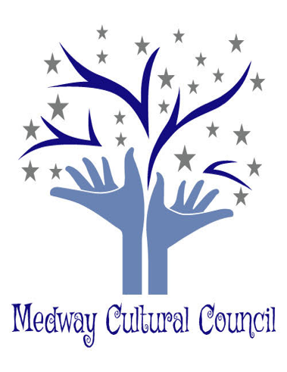

Medway Cultural Council
155 Village Street
Medway, MA. 02053
The Medway Cultural Council’s ArtWeek subcommittee meeting was held at the Medway Public Library, Medway, MA. Date: February 25, 2020. Meeting was called to order at 7:10 p.m.
Present: Carla Cataldo, Gail Hachenburg, Karyl Wong, Jennifer Kendall, Jordan Warnick, Hazel Warnick, Mary Weafer, Judith Moffatt, Winnie Nyack, Diane Busa, Kim Blenkhorn and Canman.

1. Canman
Carla attended the Selectperson’s meeting to present the CC’s idea of painting murals on the utility boxes on 109. Carla thought the idea was accepted and we approved a grant from Canman to adorn the utility boxes with murals. However, the Selectperson’s committee did not inform Carla of their decision not to have the boxes painted with murals. Once the CC members found out this project was not viable, the CC invited Canman to our subcommittee meeting to brainstorm other ideas for his grant.
Canman suggested that he paint 4 large murals about 5’x 5’, each painting would have one of the seasons of New England which would tie into the Town of Medway. He proposed that he would do live paintings on different days during ArtWeek. Locations discussed were: in front of his Tattoo Studio, Choate Park, Thayer Historical House and at one of the schools. Locations and dates that this will take place are to be determined.
Canman suggested the following:
- after the painting are completed, the CC could auction them off and all proceeds would go
to the Cultural Council for future projects etc.
- If the murals did not sell, they could be donated to Town Hall, the Senior Center, the Jacob Ide house, or local businesses.
- the murals could be loaned out to different locations and rotated throughout town.

Jennifer asked Canman to send and explanation of his above proposal.

Diane Busa suggested having a mural painted on the wall of the Cole room at the Medway Library, however the members decided to consider this at a later time as there are many committees that would need to be contacted and it may take quite a while to get on each committee’s agenda.

Action Item:
The CC members will revisit having murals painted on the utility boxes at next year’s Selectperson’s meeting.
Canman will email an explanation of what he intends to do to Jennifer.
Jennifer will work with Canman to determine the location and days that the live painting will take place during ArtWeek.

2. Promotion of ArtWeek Strategy
Carla relayed that Sandy Johnston would like to do a Medway TV interview. The format would be a panel discussion to promote ArtWeek which would include Carla, Jennifer, an artist and other members. The subcommittee members expressed interest in having Sandy do the interview and Carla volunteered to contact Sandy to set this up. Canman has offered to participate.
The following promotion strategies were discussed:
1) announcement signs (size, color, content, number) for places around town in:
a) storefronts
b) restaurants/eating establishments
c) municipal buildings include schools, library, fire and police, even dump
d) Choate sign
e) entrances and crossroads around town (Village St. and Main St., Village and
Holliston intersection, and 109 near Millis, etc.)

2) Signs for events (size, color, content, number of signs needed)
a) studio tour
b) Library events
c) Thayer Historical House Art Festival
d) The play at Medway High School
e) restaurants/eating establishments during ArtWeek

3) Dissemination of information to MCC FB, Friends of FB, other town councils
a) What will be included in the post
b) When to post the information
c) Who will be responsible to post the information

4) PR announcements to news media (Medway/Millis, etc.)
a) Who and When – Jordan and Winnie will take care of publicity

5) Deadlines for events
a) March 15 for all submissions
b) April 1 for all narratives

Action Items:
Carla will contact Sandy Johnston to set up the Medway TV interview.
Winnie will send the link to Jordan for Facebook events.
Gail and Karyl will follow up with restaurants.
Winnie and Jordan will contact Ms. O’gara about publicity in the local newspapers
All narratives should be sent to Jennifer.

3. Studio Tour Map
a) Need to find a simple map of Medway to designate location of open studios.
b) Judith would like to make an insert for the ArtWeek brochure that would include the map
of studio tours and a calendar of events containing virtual links for information
about each event.
Action Items:
Judith, Jennifer and Gail will locate a map and work on the insert.

4. Updates
a) Many of the restaurants that were contacted showed enthusiasm but have not yet
committed to participate.
b) Restaurants need to be revisited and asked if they are committed to participate
c) Discussed the number of artists that are planning on participating in ArtWeek and
how much money we have in the budget to fund the stipends of $250.00 per artist. If we
run short of money, Carla will contact the anonymous donor.
d) Next meetings: March 10 and March 24.

Action Items:
Gail and Karyl will revisit restaurants to determine if they are committed to participate.
Jennifer will determine the number of artists that are participating, and then the committee will discuss whether we have enough money in the budget to fund them. If we run short of money to fund the artists, Carla will contact the donor.

The meeting was adjourned at 8:53pm
Respectively Submitted,

Gail Hachenburg
Secretary

