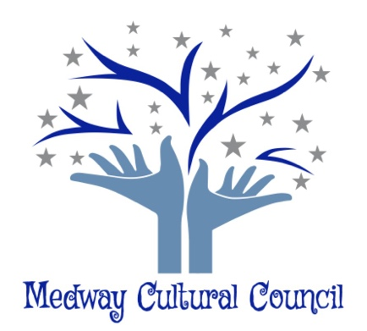 155 Village Street
Medway, Ma. 02053
May 7, 2020

ArtWeek 2020 Subcommittee Agenda May 7th at 7 pm - Virtual Meeting
Pursuant to Governor Baker’s March 12, 2020 Order Suspending Certain Provisions of the Open Meeting Law, and the Governor’s March 15, 2020 Order imposing strict limitations on the number of people that may gather in one place, no in-person attendance of members of the public will be permitted at this meeting. Access via WebEx is provided for the required opportunity for public participation at the bottom of the agenda.
ArtWeek Subcommittee Meeting Minutes
The ArtWeek Subcommittee meeting was held via webex. On May 7, 2020. The meeting was called to order at 7:22 p.m.
Present: Jennifer Kendall, Gail Hachenburg, Karyl Wong, Hazel Warnick, Jordan Warnick, Phil Giangarra.
1. Brainstorming how to turn ArtWeek events into new opportunities for artists during the Covid-19 crisis and Brainstorm other actions that the Cultural Council can take to help artists during this time of Covid 19 crisis.

Phil presented the members with four options to consider:
- Roll over the $5,000.00 until next year’s ArtWeek
- Hold ArtWeek but modify it
- Give the artists the money
- Reschedule ArtWeek at a later date.
Karyl was able to contact Mike, (Canman) and he is happy to reschedule for a later date and will discuss his proposal at a later date.
Karyl also reported that Kira has cancelled all her events in 2020 due to family medical issues.

Included in this conversation was how to proceed with Grantees. The following ideas were discussed.
- Artist’s presentations be conducted through Zoom or other online virtual sites.
- Ask Medway Cable Access to assist artists in videotaping their programs and then upload it to the Cable channel or upload to Facebook.
- Ask the artists involved in the open studio tours if they are interested in doing virtual tours.
Jordan suggested that we list all the artists from ArtWeek and Grants for the year and contact each person and find out if they are willing to do a demonstration. Find out if they can arrange a video or if the Medway Cable Access will do a video. Based on the interest, we move forward.
Hazel relayed that the play will be broadcasted on Zoom in May. At that time, it was discussed that the $600.00 that was granted for the play should be allotted and to inform Thea what process she needs to do for that transaction. In addition, concern about the $250.00 per artists for ArtWeek was discussed.

Also discussed was that if Grantees want an extension, they need to put it in writing, which is current protocol. Also needed addressing is whether Winnie will need to do another extension, or if she is allowed to do a second extension as her first extension was granted in February 2020. This will be brought forth during the Cultural Council meeting in June 2020.
Jordan made the motion that the ArtWeek Committee move forward with the recommendations made at the May 7, 2020 meeting to engage the artists for the annual events and ArtWeek for virtual activities. Motion was approved

Action Items:
Karyl will contact Medway Cable to find out if this is a viable option.
Jordan and Jennifer will reach out to the artists who were slated to do the open studios tours.
Karyl will look into the Mass Cultural site to see if there is information about grant modification, Covid -19 relief funds.
Karyl will send out emails to Grantees to and ArtWeek artists to find out if they are still interested.
Phil will find out if we need to give back the $5,000.00 to the Town of Medway.
Discuss the issue of granting extensions to the Grantees at the June CC meeting.

The meeting was adjourned at 8:20pm
Respectively Submitted,

Gail Hachenburg
Secretary

