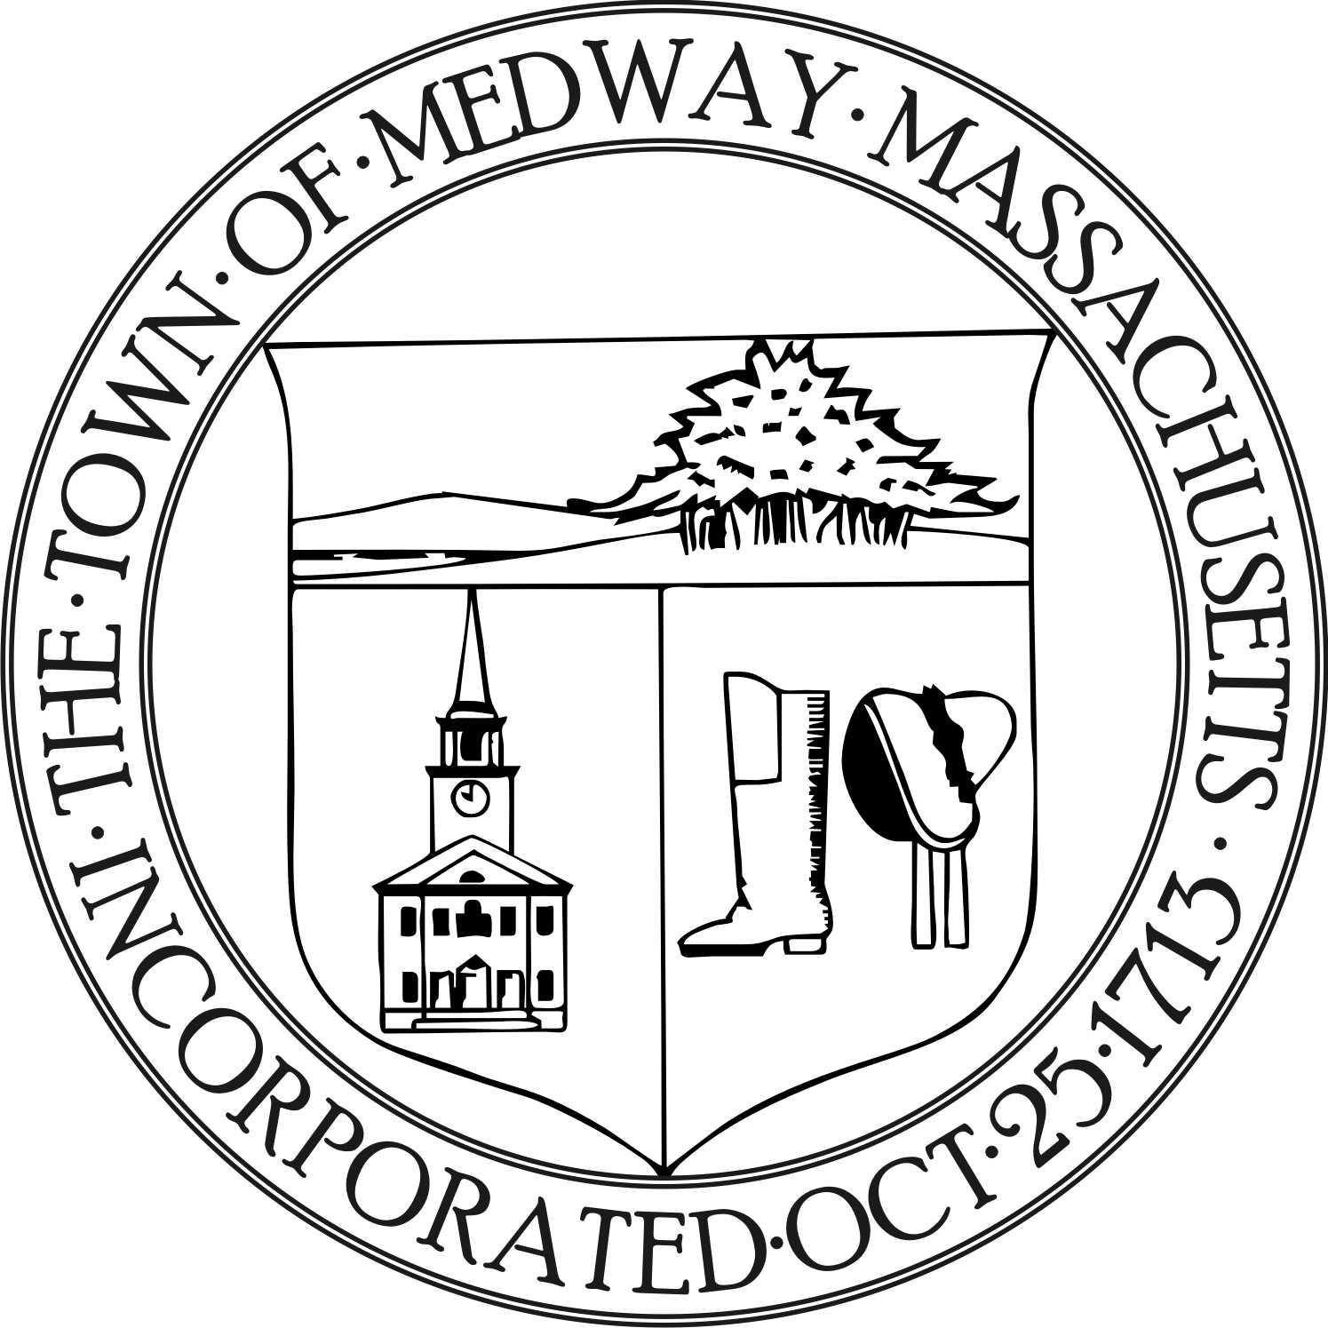

Medway Energy Committee
Town of Medway
155 Village Street
Medway, MA 02053
Tel: 508-533-3264 / Fax: 508-533-3281

Meeting Date: October 17, 2018
Meeting Location: Medway Public Library
Approved:
Attending: Carey Bergeron, Chair, Larry Ellsworth, Stephanie Carlisle,
Kristen Rice, Alex Siekierski, Mark Lannigan, President, Project
Green- Medway High School and Tracy Rozak, Committee Secretary
_______________________________________________________________________________________

- Call to Order

- Carey Bergeron called the meeting to order at 7:37 pm.

Carey introduced Mark to the committee members. Carey stated she would like to get some of the Project Green students involved in the Energy Committee so they can learn about the town government. Mark stated they have worked with the school, the community farm and the fall festival but would like to get involved in the greater community. Their primary job within the school is to take care of the green house. They have about 3-4 dozen plants in there. They also do a recycling drive at the school every year –did a shoe and electronics drive. Recently, a commissioner from Medway and Millis came in to talk about solar energy and energy use at school. They also did a green scavenger hunt around the school.

Carey suggested one of the energy meeting members go to one of the Project Green meetings. Mark stated they meet every other Tuesday after school. October 30th is the next meeting. Mark stated they would love to get involved with any projects that the energy committee needs help with.

- Project Discussion

- Municipal Aggregation next steps

- Meeting Minutes

No meeting minutes were approved at this meeting.

- Compliance Coordinator Update

Stephanie talked about the DPS base building. She heard the final bid is 13.68 million and they are aiming for net zero. Larry stated that it is a net zero design. Construction estimates have been done and the bid documents will go out in February. The PV Array includes solar panels on the roof and the parking canopy which generates heat. Natural Gas will be the back- up. There is a lot more to do with the analysis and they hope to go to the town meeting in May. Stephanie talked about alternates to the contract. Larry stated that Glenn noted they will be looking into alternate funding sources or offsets. 12.1 million will be the amount needed for town approval. Another 1.5 million if you include the Photo Array. The next step is to give a presentation to the Board of Selectman next week. They will vote on it and if approved, they will then focus on PR efforts. Larry stated that research has shown that after nine years the project will be paid for. The building will be built on part of the old parcel and part on the new parcel.

Stephanie is still working on getting contracts and stated things should be done by the next meeting. Stephanie stated we don’t have a meeting scheduled for Thanksgiving week. It was decided to have the next meeting on November 14th. .

Stephanie brought in some data from MEI (Mass Energy Insight). She stated our energy consumption has gone up from last year. She noted that Thayer House was excluded from the first year. Prism Energy did some audits and she also has TNT audits from ten years ago. Stephanie stated the middle school and the high school are the biggest energy consumers. Alex suggested that all new buildings should have regular occupancy audits every 5 years or so. It was also suggested to get other people and committees involved with the Energy Meetings–the School Committee liaison, John Forresto, DPS. Alex may invite his friend who is a Sustainability Project Manager to come to one of our meetings.

Alex stated that Shelley sent him some of the older documents and he merged all that that with the new system in Google Docs. All committee members have access and editing rights. He also created a folder called Projects. Carey will review those folders.

5. Report from the Chair

Carey stated that next Monday at 3pm, Joe Kennedy and Next Amp Solar will be touring the Medway High School to review the solar project at the school. Carey invited committee members and Mark to attend. Medway Pride Day is coming up and the Energy Committee might want to get involved with that. Carey also mentioned there is some money in the budget to take an energy related course or seminar. It was noted that the Energy Committee has a logo – it is a green footprint. Carey mentioned that Susan Affleck Childs sent her some information about a non-profit company called the Center for Echo Technology that offers affordable access funded by Mass Energy Resources & Mass Clean Energy Center that provides solar panels, heat pumps and an energy coach.

- New Business

None
- Future Topics / other business
None
- Action Items
- Adjourn
- Carey made a motion to adjourn the meeting at 8:38 pm. Larry seconded the motion and all were
in favor.

* Next meeting will be on Wednesday, November 14, 2018 at 7:30 pm at the Medway Public Library.
Respectfully submitted by Tracy Rozak

