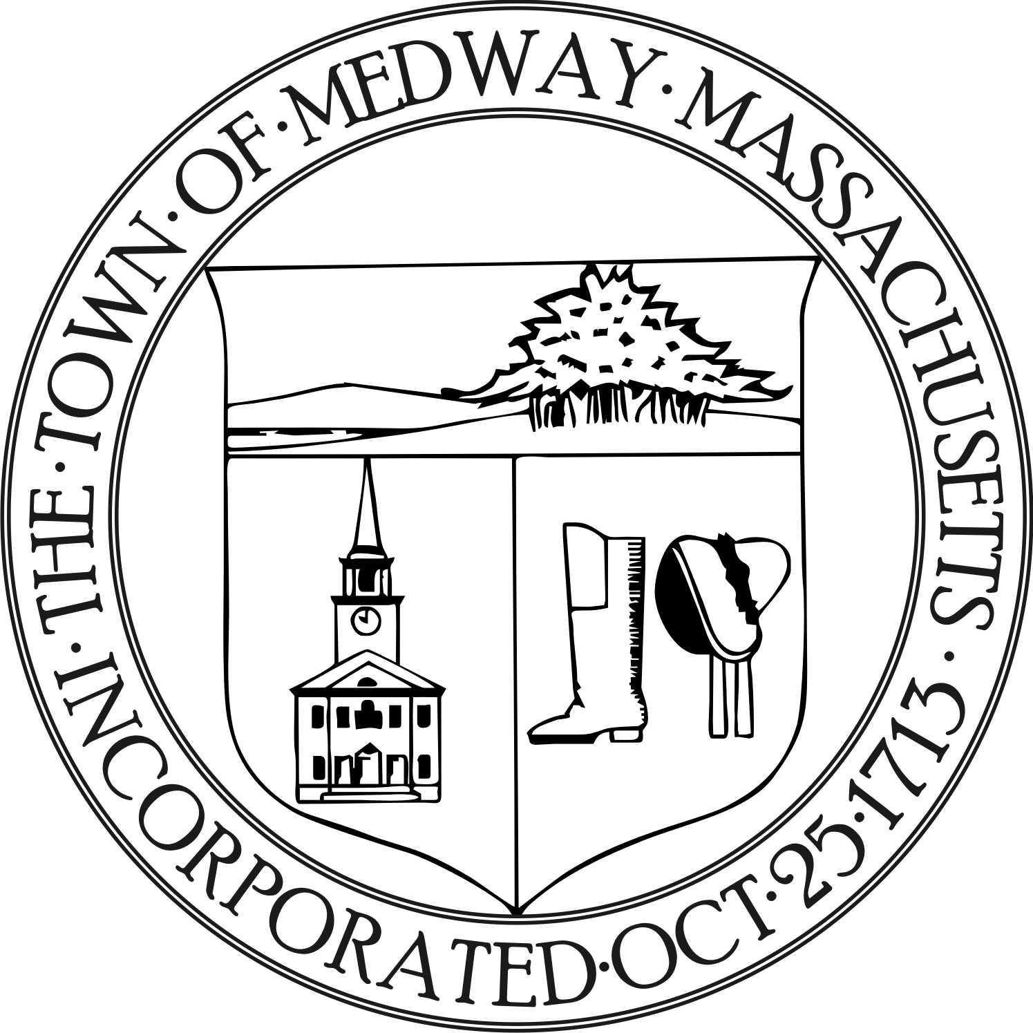

Medway Energy Committee
Town of Medway
155 Village Street
Medway, MA 02053
Tel: 508-533-3264 / Fax: 508-533-3281

Meeting Date: September 19, 2018
Meeting Location: Medway Public Library
Approved:
Attending: Carey Bergeron, Lawrence Ellsworth, Stephanie Carlisle,
Compliance Coordinator, Kristen Rice, Alex Siekierski
and Tracy Rozak, Committee Secretary
_______________________________________________________________________________________

- Call to Order

- Carey Bergeron called the meeting to order at 7:37 pm.

- Project Discussion
- Municipal Aggregation next steps

- Meeting Minutes

No minutes were approved at this meeting.

- Compliance Coordinator Update

After a brief discussion it was decided that the agendas will remain general and Stephanie will post them to the towns website. Tracy will continue to send the draft meeting minutes to Carey and she will send them to the rest of the group. The meeting minutes should be reviewed so they can be approved at the next meeting and posted to the Google drive. Alex will look into creating a Google website /drive where all working documents can be organized by folders such as: Agendas, Minutes, Green Communities, Community Aggregation, 5-10 year plan, Medway’s Master Plan. Other people can be given guest access if needed. Alex will link the shared calendar to it.

Stephanie reported that the Ever Source reps came out last week and they are working on contracts. They will be covering the installation costs of the electric car charging stations. This will save the town about 15K. The stations have to be located on public property and they will need an easement so that Ever Source can get in to maintain them. There has to be a conduit for 5 ports at each location, there will be one at the library and one at the town hall. These stations could be installed by November if all goes well. There was a brief discussion about charging to use the stations or having them be free. Should the rate be variable for peak times? It was noted that the city of Newton uses a card swipe system and they charge twenty cents per kilowatt hour. An average charge can take up to 3-4 hours. Carey stated we should figure out the savings on gas and use this info to show how much we are saving as a Green Community.

Stephanie also reported that she has been working on BOC training and learning about HVAC systems.
Stephanie will take a closer look at the Mass Energy Insight Account. We are supposed to be saving 20% and saved 7% last year and 5% this year. We don’t want to lose our Green Communities status so we need to figure out why the savings has gone done and what can be done. Stephanie will bring an overview/summary of the data to the next meeting for the members to review.

Report from the Chair

Carey stated now is a good time to look at projects to work on this year. She would like us to be good stewards and help with the solid waste program. She would also like to get more articles in the newsletter. In addition, she wants to focus more on outreach, raising awareness and getting involved with other groups like the green team at the high school. Carey will reach out to her Green Communities contact by the next meeting. There was a brief discussion about taping the MEC meetings and uploading them to Social Media. Kristen will speak to Sandy Johnson (PR) and find out about the rules for posting to Facebook or the towns website. Alex asked if Mass Save has any incentives for municipal buildings like they do for private residences. Alex will check into that. Larry will attend the CIPC Capital Improvement Planning Committee meeting on October 3rd.

- New Business

None
- Future Topics / other business
None
- Action Items
- Alex will create a Google website/drive and link the shared calendar to it.
- Carey will bring the Medway Master Plan to the next meeting to review.
- Stephanie will bring a summary of the Mass Energy Insight Account to the next meeting.
- Carey will reach out to her Green Communities contact person.
- Alex will look into Mass Save Incentives for municipal buildings
- Kristen will contact Sandy Johnson about posting videos.
- Larry will bring back information from the October CIPC meeting.

- Adjourn
- Larry made a motion to adjourn the meeting at 8:40 pm. Alex seconded the motion and all were
in favor.

* Next meeting will be on Wednesday, October 17, 2018 at 7:30 pm at the Medway Public Library.

Respectfully submitted by Tracy Rozak

