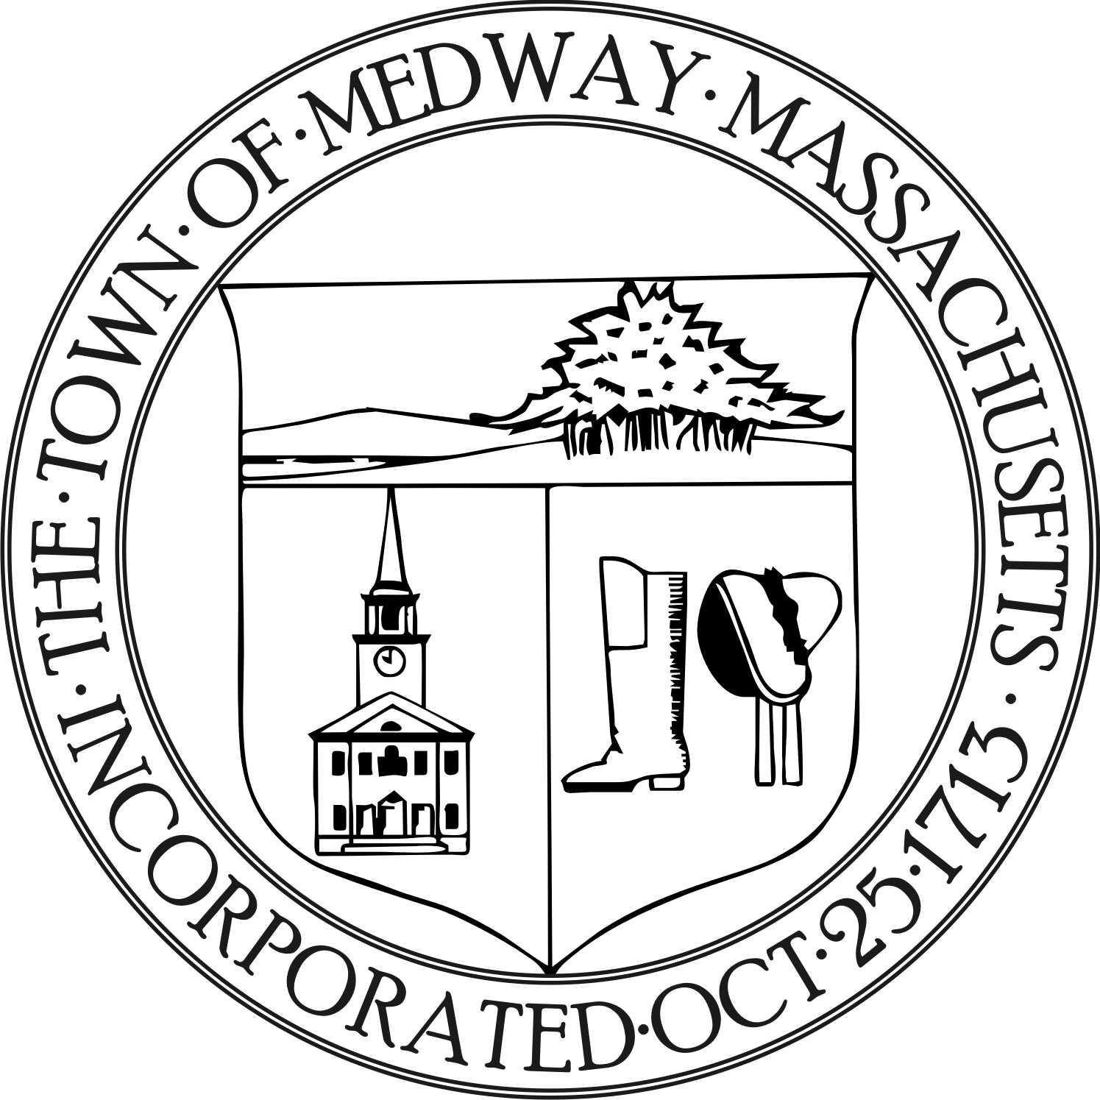
Medway Energy & Sustainability Committee
Medway Public Library, Conference Room
September 18, 2019 at 7:00 PM

Members present: Carey Bergeron, Lawrence Ellsworth, Alex Siekierski, Kristen Rice, Stephanie Carlisle, and Tracy Rozak, Recording Secretary * Lawrence Ellsworth arrived at 7:30 pm

Also present: Ben Hellerstein, Mike Caine from Ashland

Call to Order
Carey called the meeting to order at 7:10 pm.

Mike Caine introduced himself to the committee and stated he is proposing to install two separate solar farms. One will be on Lovering Street and the other on Summer Street. They are two farm properties, the Iarrussi property and the Panachelli property. They are located in existing fields so there would be very little tree clearing. They will be built on very tall extensions so that hay can still grow underneath. They will be 250 kilowatt hours DC each, 675 kilowatt hours DC under the Smart Program. Mike stated he is going to the ZBA for a land use variance for solar and he would like the support of this committee. Steve Kenney is his attorney and is speaking with the town council about the legal stuff. They would be leasing the land for 20 years and the revenue would come to him and be payment in lieu of taxes. Mike stated it’s critical to get this project going before the end of the year for incentive reasons. He stated the town will get some rent and Medway becomes a little greener.

There was a brief discussion about the pros and cons of the proposed solar farms. Some members feel it is better to put solar panels on top of existing town owned buildings rather than take up farmland. This project is a private entity and the members questioned the legality of supporting a for profit business. The committee would like to get more information on how this project would actually help Medway. The committee decided to look at the list of town owned buildings that might be suitable for a solar farm.

Report from the Chair
Reports from Members
Ongoing Project Discussion
Green Communities grant update

Update the group on the Charles River Climate Compact
There is a meeting October 3rd. Carey got an e mail about it and she will forward it to the other members.
New Business
a. Guest: Ben Hellerstein, State Director from Environment Massachusetts
Ben introduced himself to the committee and stated he works for Environment Massachusetts which is a statewide citizen supported agency that supports clean water and air. They work on a variety of things such as saving the bees from pesticides, protecting oceans from plastics, protecting waterways from sewage etc. Their big focus now is on renewable energy. They would like to move Massachusetts to a 100 percent renewable energy state. Solar, off shore wind potential, electric vehicles are all good sources of renewable energy. Mass has been a leader in clean energy policies and we need to take the lead now. He is working on the 100% Renewable Energy Act and hopes to get this bill passed. They are also working with local municipalities and colleges to get them on board. He asked if the committee could sign the letter of support that he distributed to the committee. He also asked if the committee members could meet with local business leaders or state representatives and encourage their support. Ben will also invite committee members to any in-district meetings. Ben stated the deadline for submissions is February. Carey stated she feels like most people are talking about what they can do when there is a crisis and we should focus on preventing the crisis. Be proactive instead of reactive.
Ben has been encouraging towns to use the zoning codes to get around some of the building restrictions. They try to shift new buildings to use heat pumps and solar panels. Carey asked what some of the surrounding towns are doing. Ben stated he can look into that and send some data to her on that.
Ben explained that if the bill passes, it would require Energy companies to be using 100% renewable energy by 2025. The state would have to come up with their own plan to increase renewable resources in ground transportation and heating in buildings.
The committee liked the idea of the 100% Renewable Energy Act and discussed the pros and cons of signing the letter of support that Ben proposed.
b. Review MEI data
Action Items
- Stephanie will provide the committee with a list of town owned buildings and properties with the square footage.

Schedule November and December meetings
The meeting in October has changed. It will be On October 23rd at 7:30 pm. The November meeting will be on November 20th and the December meeting will be on December 18th.
State of the Town report items
Future topics / other business
Temperature Set Point Policy
Plastic bag ban
Community Choice Aggregation
Solar panel regulation
Composting
5 year plan
Website update

Adjourn
Carey made a motion to adjourn the meeting at 8:40 pm. Kristen seconded the motion and everyone was in favor.

Respectfully submitted by,
Tracy Rozak

